

NOVAC TECHNOLOGY SOLUTIONS

User Manual

Document Version No.: 1.00

Revision History
Version No | Reason For Changes | Author | Approver
0.01 | Draft | RAVI
1.00 | Reviewed & Approved the User Manual | RAVI | NIJANTHAN PL

Table of Contents
1. Introduction 4

2. Renewal Premium Notice 4

3. Renewal Premium Notice Reprint 4

Introduction

The document is prepared to understand the reports generated in ZIVA application. This document is being prepared in reference to,
- Guidelines, circulars, instructions and directions released from time to time by Philippines Insurance council.

1.1 Functional Overview

To process the renewal for expiring policy, generate the renewal notice document and email the renewal notice document to customer from the ZIVA system.

Renewal Premium Notice
- System should have the provision to process the renewal for expiring policy based on the input parameter.
- Once the renewal process is done then system should enable the Process download button to generate the renewal processed policy list with the batch number in Excel format.

Search the Renewal Premium Notice.

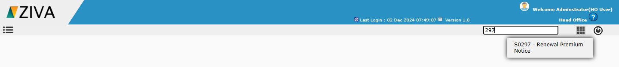

Click on the Renewal Premium Notice Screen. System will display the Renewal Premium notice screen.

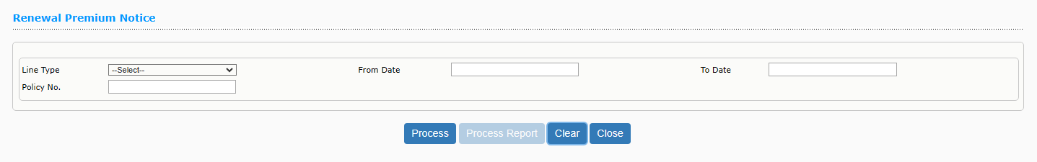

Enter all the details and click on Process button.

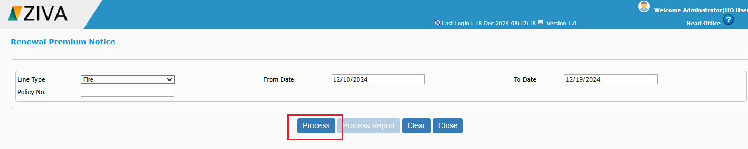

Once click on the Process button system will display an alert message as “Batch successfully Processed “. You may now close this window by clicking ok Button.



Click on the Process report Button.

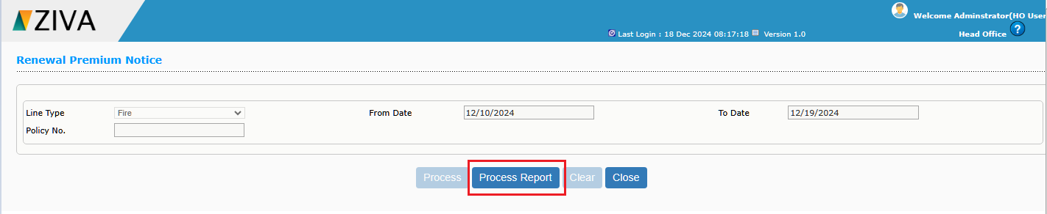

Once click on the Process report Button, system will download the Renewal Premium notice report.

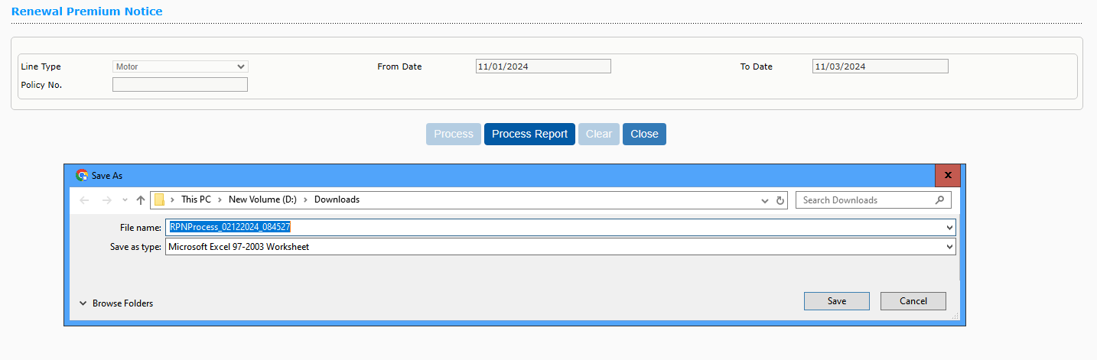

Renewal Notice Reprint
- System should have the provision to generate the renewal notice for Renewal processed policy records and send an email the renewal to Customer (or) Agent / Broker.
Search the Renewal Premium Notice.
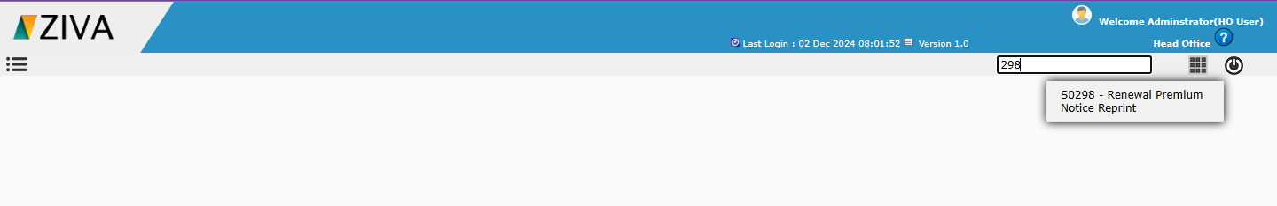

Click on the Renewal Premium Notice Reprint Screen. System will display the Renewal Premium notice Reprint screen.
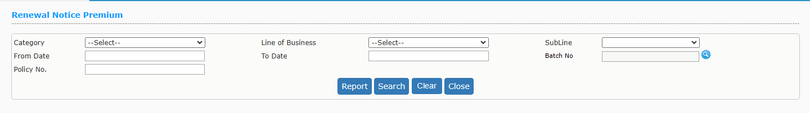

Enter all the details and click on Search button, system will display the Batch Report. .
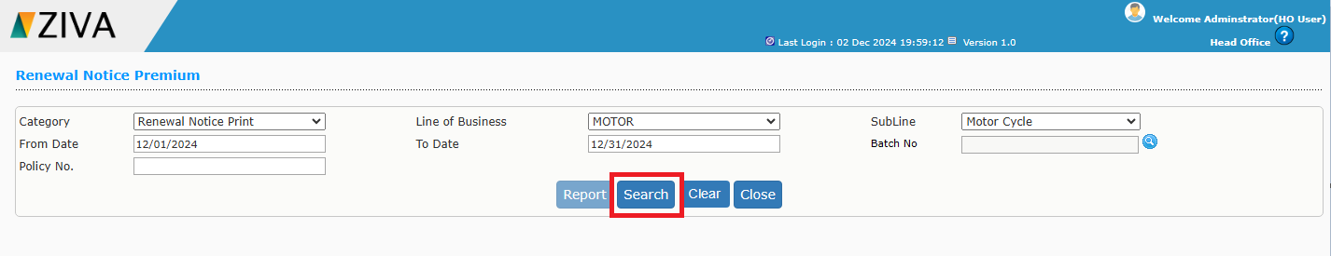
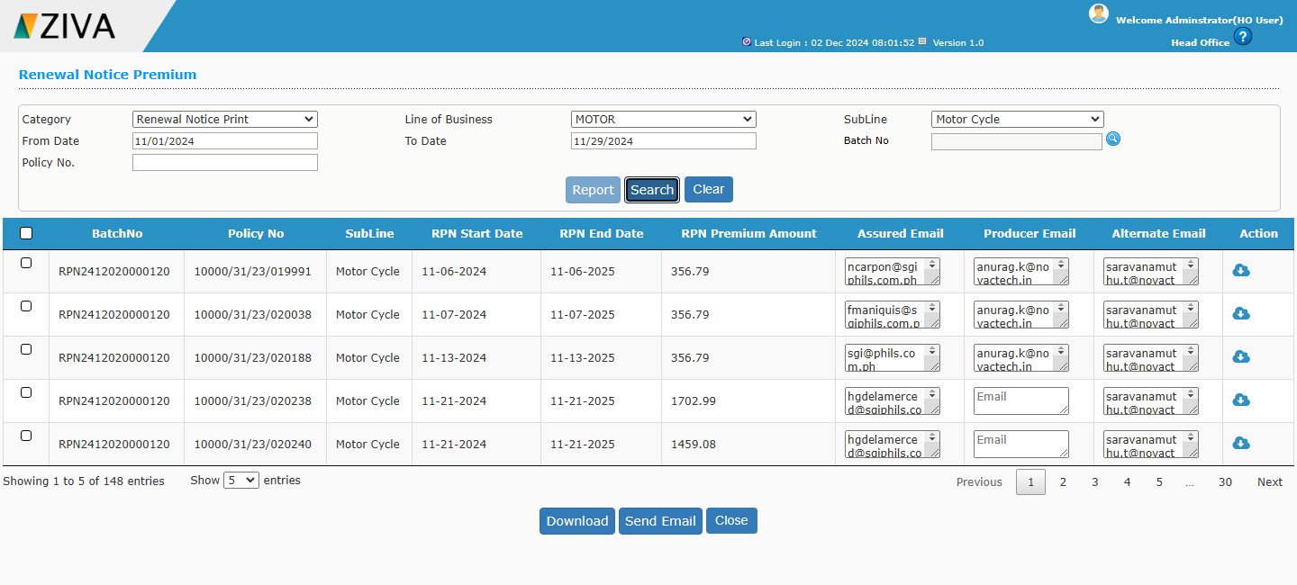

Click on the Download Button, system will download the Selected batch report.

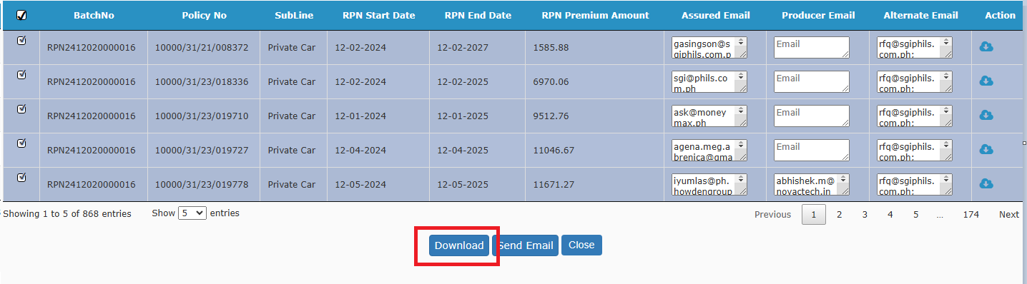

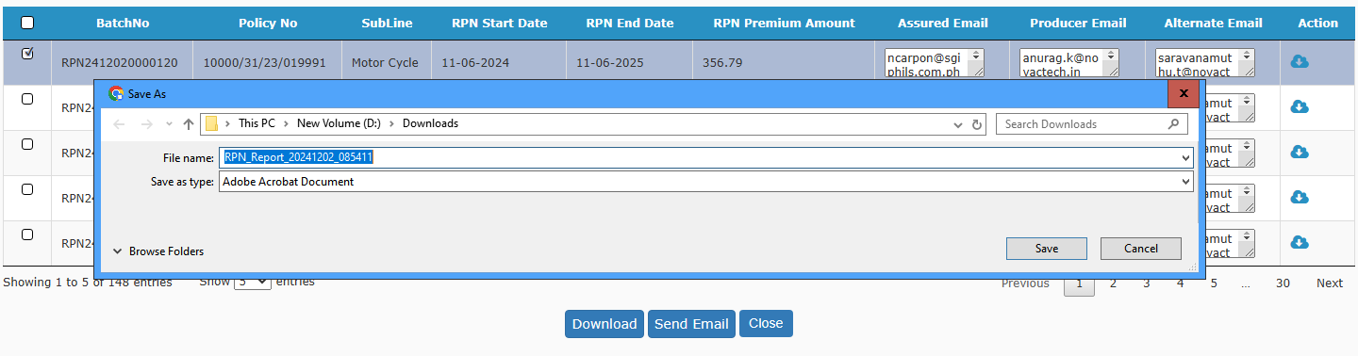

Once click on the Email button, system should send the email to the respective email id’s with the attached renewal notice document for all selected records.
